Class 7

**Lecture 9**

**Web & Internet**

**Connectivity, Connection Type Bandwidth**

**Internet**

**&**

**Web**



**Lab Objectives:**

* Connectivity
* What is Internet Access?
* What is Bandwidth, How does it work?

**What is Connectivity?**

Connectivity is a generic term for connecting devices to each other in order to transfer data back and forth. It often refers to network connections, which embraces bridges, routers, switches and gateways as well as backbone networks. It may also refer to connecting a home or office to the Internet or connecting a digital camera to a computer or printer.

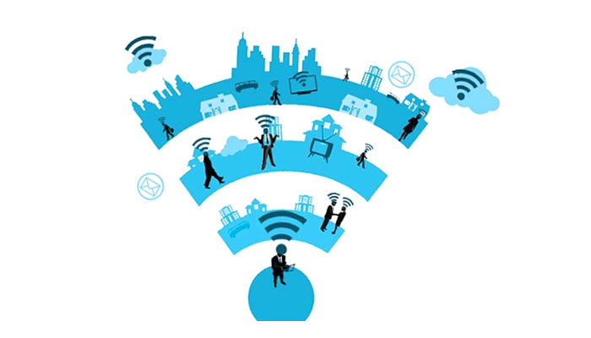

**What is Internet Access?**

Internet access is the ability of individuals and organizations to connect to the Internet using computer terminals, computers, and other devices; and to access services such as email and the World Wide Web.

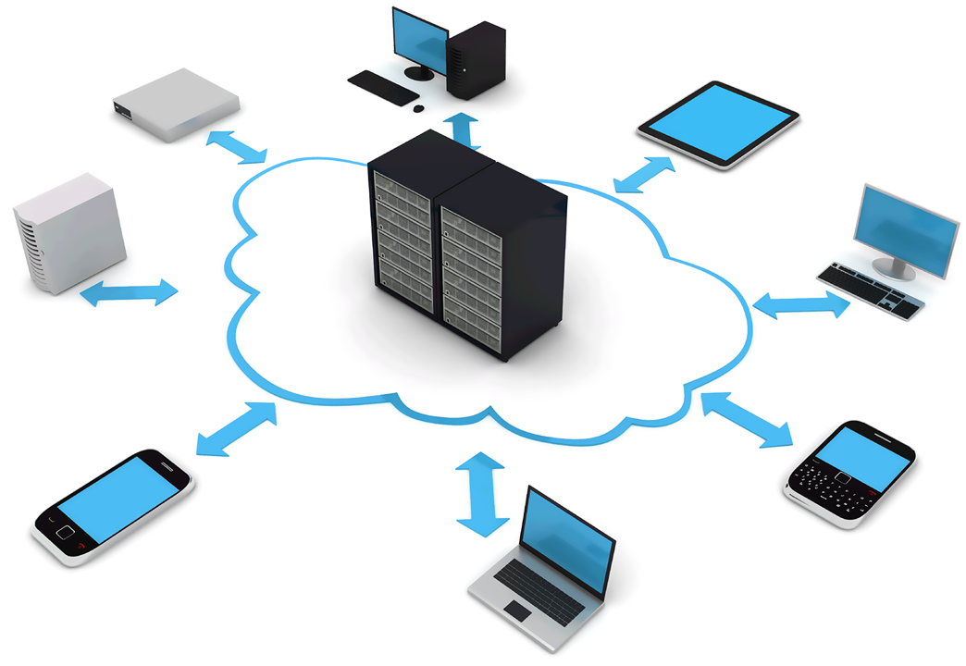

**Frequent Internet Connection Type**

There are many ways a personal electronic device can connect to the internet. They all use different hardware and each has a range of connection speeds. As technology changes, faster internet connections are needed to handle those changes. In today's age, there are numerous ways to connect laptops, desktops, mobile phones, gaming consoles, e-readers and tablets to the Internet. Some of the most widely used Internet connections are described below.

**WIRELESS**

Radio frequency bands are used in place of telephone or cable networks. One of the greatest advantages of wireless Internet connections is the "always-on" connection that can be accessed from any location that falls within network coverage. Wireless connections are made possible through the use of a modem, which picks up Internet signals and sends them to other devices.

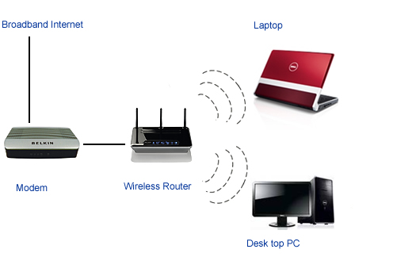

**MOBILE**

Many cell phone and smartphone providers offer voice plans with Internet access. Mobile Internet connections provide good speeds and allow you to access the Internet on the go.

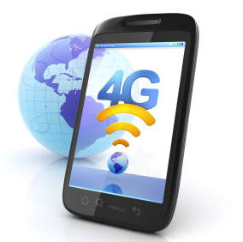

**BROADBAND**

This high-speed Internet connection is provided through either cable or telephone companies. One of the fastest options available, broadband Internet uses multiple data channels to send large quantities of information. The term broadband is shorthand for broad bandwidth. Broadband Internet connections such as DSL and cable are considered high-bandwidth connections.

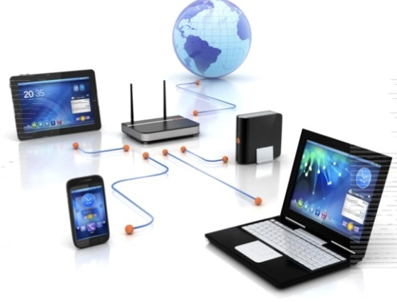

**SATELLITE**

In certain areas where broadband connection is not yet offered, a satellite Internet option may be available. Similar to wireless access, satellite connection utilizes a modem. Satellite connection speeds are around 512K to 2.0 Mbps.

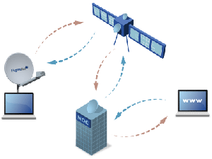

**Bandwidth**

Bandwidth is the capacity of a wired or wireless network communications link to transmit the maximum amount of data from one point to another over a computer network or internet connection in a given amount of time -- usually one second.

So, Bandwidth is the maximum rate of data transfer across a given path. The more bandwidth a data connection has, the more data it can send and receive at one time. Bandwidth can be compared to the amount of water that can flow through a water pipe. The bigger the pipe, the more water can flow through it at one time. Bandwidth works on the same principle.

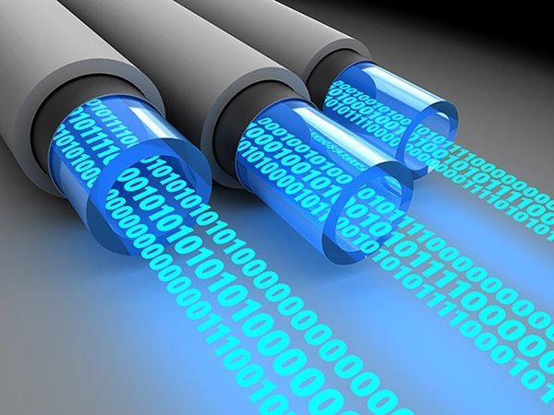

**How Does Bandwidth Work?**

Say 1 Mbps is the equivalent to a 1 lane freeway. And let’s say that you were trying to download an image, which is 5 Mb in size. So if you had a bandwidth of 1 Mbps (1 lane freeway) it would take you roughly 5 seconds to download the image. Now let’s say that you have a 5 Mbps (bandwidth) connection, or a 5 lane freeway. How fast will you receive your image?

1 second!

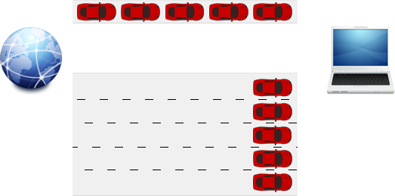

**Common terminology**

**Kbps** – Kilobits per second. This is used when talking about dialup (56k for example) and low speed DSL.

**Mbps or mbps** – Megabits per second. Some people confuse this with megabytes. The difference between the two is how the “b” is written in the abbreviation; Mbps = megabits and MBps = megabytes. This is the most common unit of speed used.

**MBps** – Megabytes per second. Megabytes aren’t usually used in (residential) internet plans.

**Gbps** – Gigabits per second. Gigabits are hardly used for internet plans, and the costs make them unpractical for families and small businesses.